**Addressing Table**

|  |  |  |  |
| --- | --- | --- | --- |
| **Device** | **Interface** | **IP Address** | **Default Gateway** |
| College | G0/0 | 128.107.20.1/24 | N/A |
| *College* | *G0/0* | 2001:DB8:A::1/64 | *N/A* |
|  |  | FE80::3 |  |
| *College* | G0/1 | 128.107.30.1/24 | N/A |
| *College* | *G0/1* | 2001:DB8:B::1/64 | *N/A* |
|  |  | FE80::1 |  |
| Class-A | VLAN 1 | 128.107.20.10/24 | 128.107.20.1 |
| Class-B | VLAN 1 | 128.107.30.15/24 | 128.107.30.1 |
| Student-1 | NIC | 128.107.20.25/24 | 128.107.20.1 |
| *Student-1* | *NIC* | 2001:DB8:A::25/64 | FE80::3 |
| Student-2 | NIC | 128.107.20.30/24 | 128.107.20.1 |
| *Student-2* | *NIC* | 2001:DB8:A::30/64 | FE80::3 |
| Student-3 | NIC | 128.107.30.25/24 | 128.107.30.1 |
| *Student-3* | *NIC* | 2001:DB8:B::25/64 | FE80::1 |
| Student-4 | NIC | 128.107.30.30/24 | 128.107.30.1 |
| *Student-4* | *NIC* | 2001:DB8:B::30/64 | FE80::1 |

**College Router**

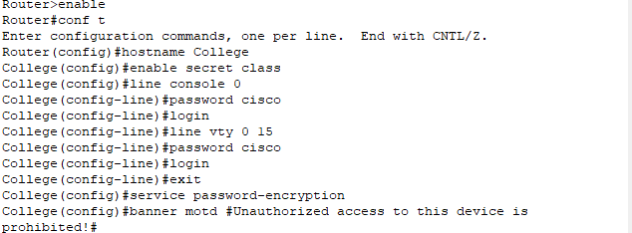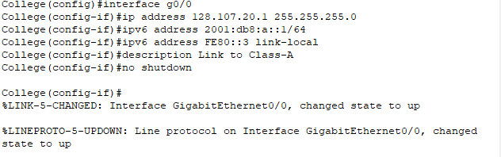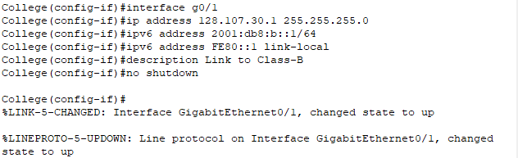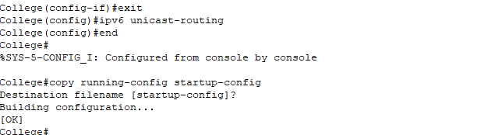

**Class-B Switch**

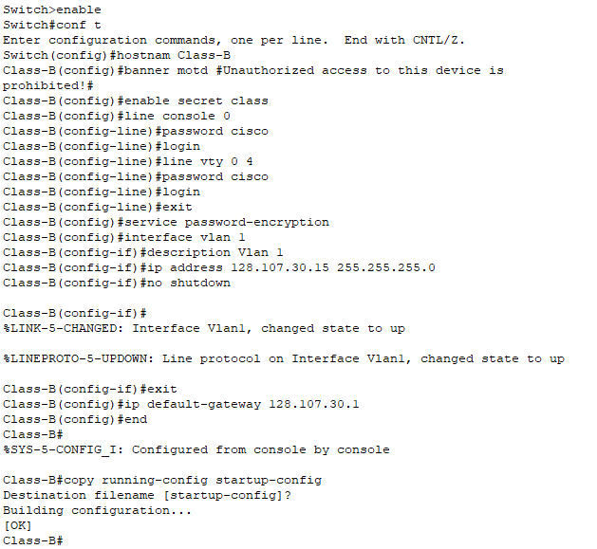

**PCs host**

